**5 PROGRAM**

**SERVER**

ARP Server in Java

Listens for IP requests and responds with MAC address

import java.io.*;

import java.net.*;

import java.util.HashMap;

public class AkshayaARPServer {

public static void main(String[] args) {

int port = 8888;

// akshaya: Create a simulated ARP table (IP -> MAC)

HashMap<String, String> arpTable = new HashMap<>();

arpTable.put("192.168.1.1", "AA:BB:CC:DD:EE:01");

arpTable.put("192.168.1.2", "AA:BB:CC:DD:EE:02");

arpTable.put("192.168.1.3", "AA:BB:CC:DD:EE:03");

try (ServerSocket serverSocket = new ServerSocket(port)) {

System.out.println("akshaya: ARP Server is running...");

while (true) {

Socket socket = serverSocket.accept();

System.out.println("akshaya: Connected to client");

BufferedReader in = new BufferedReader(

new InputStreamReader(socket.getInputStream()));

PrintWriter out = new PrintWriter(socket.getOutputStream(), true);

String ip = in.readLine(); // akshaya: Read IP from client

System.out.println("akshaya: Received IP: " + ip)

String mac = arpTable.getOrDefault(ip, "MAC not found");

out.println(mac); // akshaya: Send MAC back to client

System.out.println("akshaya: Sent MAC: " + mac);

socket.close();

}

} catch (IOException e) {

System.out.println("akshaya: Server error: " + e.getMessage());

}

}

}

**CLIENT :**

ARP Client in Java

Sends IP address to server and receives MAC

import java.io.*;

import java.net.*;

import java.util.Scanner;

public class AkshayaARPClient {

public static void main(String[] args) {

String serverIP = "127.0.0.1"; // akshaya: change if server is remote

int port = 8888;

try (Socket socket = new Socket(serverIP, port)) {

BufferedReader in = new BufferedReader(

new InputStreamReader(socket.getInputStream()));

PrintWriter out = new PrintWriter(socket.getOutputStream(), true);

Scanner scanner = new Scanner(System.in);

System.out.print("akshaya: Enter IP to resolve: ");

String ip = scanner.nextLine();

out.println(ip); // akshaya: Send IP to server

String mac = in.readLine(); // akshaya: Receive MAC

System.out.println("akshaya: MAC address is: " + mac);

} catch (IOException e) {

System.out.println("akshaya: Client error: " + e.getMessage());

}

}

}

**OUTPUT :**

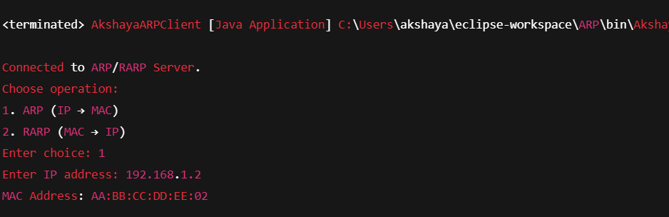

**6.PROGRAM :**

**SERVER**

RARP Server using UDP

import java.net.DatagramPacket;

import java.net.DatagramSocket;

import java.util.HashMap;

public class RarpServer {

public static void main(String[] args) {

int port = 9876;

// akshaya: Mock RARP table (MAC -> IP)

HashMap<String, String> rarpTable = new HashMap<>();

rarpTable.put("AA:BB:CC:DD:EE:01", "192.168.1.1");

rarpTable.put("AA:BB:CC:DD:EE:02", "192.168.1.2");

rarpTable.put("AA:BB:CC:DD:EE:03", "192.168.1.3");

try (DatagramSocket serverSocket = new DatagramSocket(port)) {

byte[] receiveData = new byte[1024];

byte[] sendData;

System.out.println("akshaya: RARP Server is running...");

while (true) {

// akshaya: Receive request

DatagramPacket receivePacket = new DatagramPacket(receiveData, receiveData.length);

serverSocket.receive(receivePacket);

String mac = new String(receivePacket.getData(), 0, receivePacket.getLength());

System.out.println("akshaya: Received MAC: " + mac);

// akshaya: Look up IP

String ip = rarpTable.getOrDefault(mac, "IP not found");

// akshaya: Send response

sendData = ip.getBytes();

DatagramPacket sendPacket = new DatagramPacket(sendData, sendData.length,

receivePacket.getAddress(), receivePacket.getPort());

serverSocket.send(sendPacket);

System.out.println("akshaya: Sent IP: " + ip);

}

} catch (Exception e) {

System.out.println("akshaya: Server error: " + e.getMessage());

}

}

}

**CLIENT :**

RARP Client using UDP

import java.net.DatagramPacket;

import java.net.DatagramSocket;

import java.net.InetAddress;

import java.util.Scanner;

public class RarpClient {

public static void main(String[] args) {

Scanner scanner = new Scanner(System.in);

try (DatagramSocket clientSocket = new DatagramSocket()) {

InetAddress serverAddress = InetAddress.getByName("localhost");

int port = 9876;

System.out.print("akshaya: Enter MAC address: ");

String mac = scanner.nextLine();

// akshaya: Send MAC

byte[] sendData = mac.getBytes();

DatagramPacket sendPacket = new DatagramPacket(sendData, sendData.length, serverAddress, port);

clientSocket.send(sendPacket);

// akshaya: Receive IP

byte[] receiveData = new byte[1024];

DatagramPacket receivePacket = new DatagramPacket(receiveData, receiveData.length);

clientSocket.receive(receivePacket);

String ip = new String(receivePacket.getData(), 0, receivePacket.getLength());

System.out.println("akshaya: IP Address is: " + ip);

} catch (Exception e) {

System.out.println("akshaya: Client error: " + e.getMessage());

}

}

}

**OUTPUT**

